BACK TO MAIN TOC

Column Tests

Column Specifications and Design
Appendix D
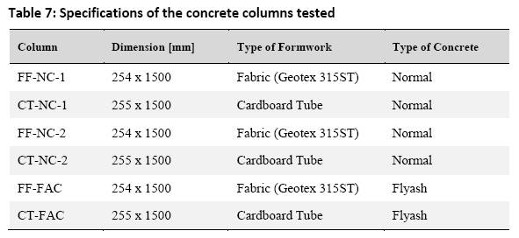Table 7: Specifications of the concrete columns tested
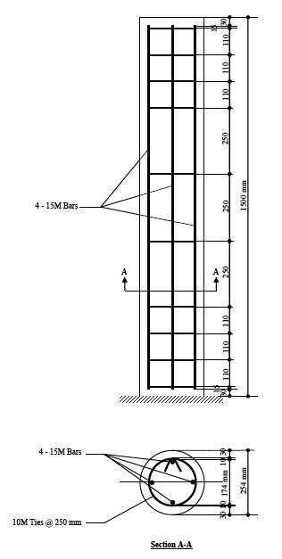Array

Column Casting

Formwork
«fs medium>The cover distance between both fabric and cardboard formworks was maintained by using plastic wheel spacers on the longitudinal bars. These spacers were also used to keep the reinforcement cage in the centre of the formwork during casting as shown in Figure 46.</fs>
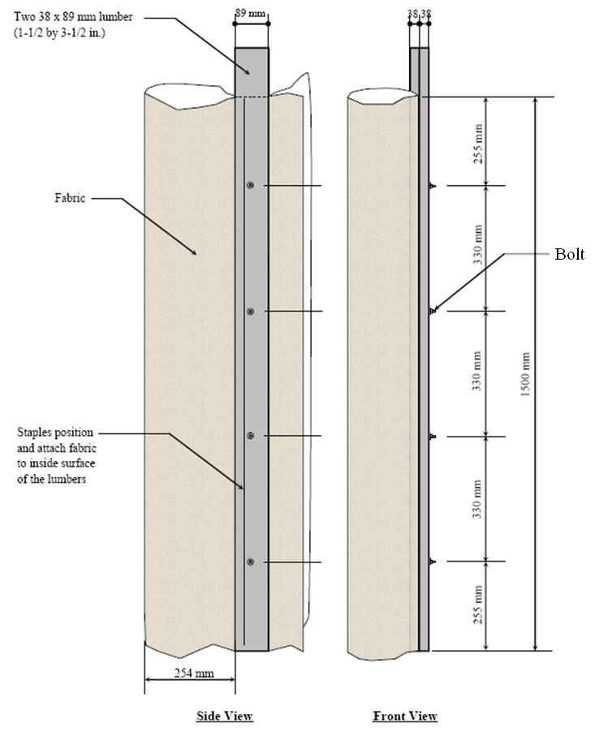Array
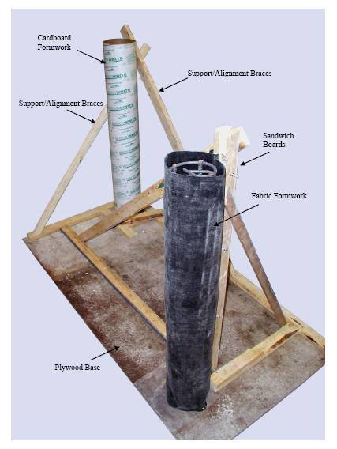Array
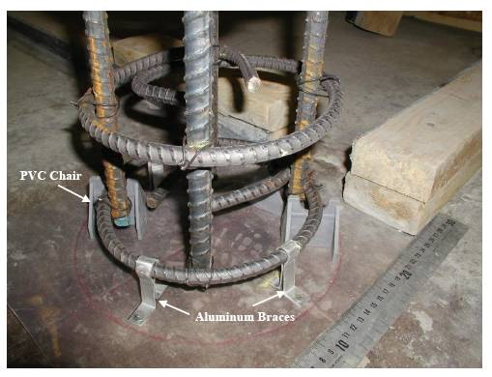Array
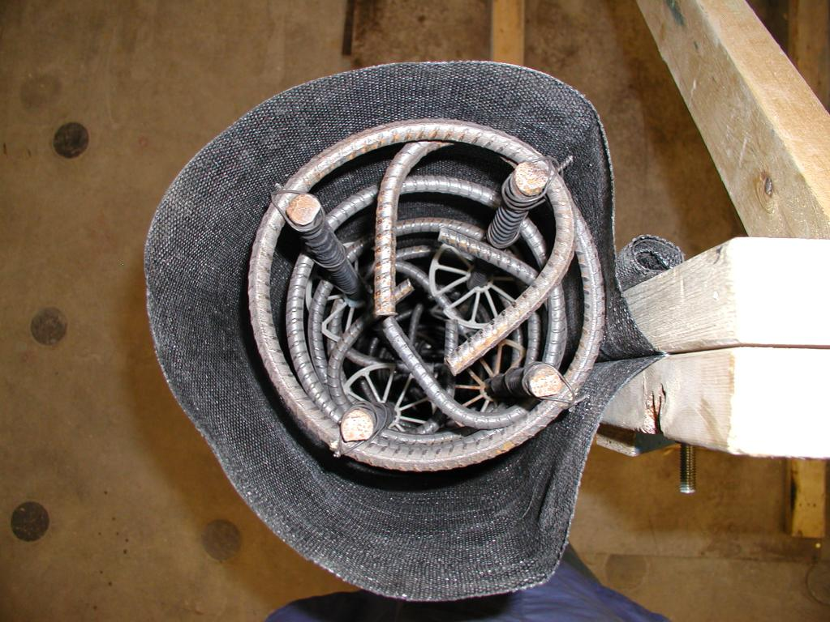Array

Concrete
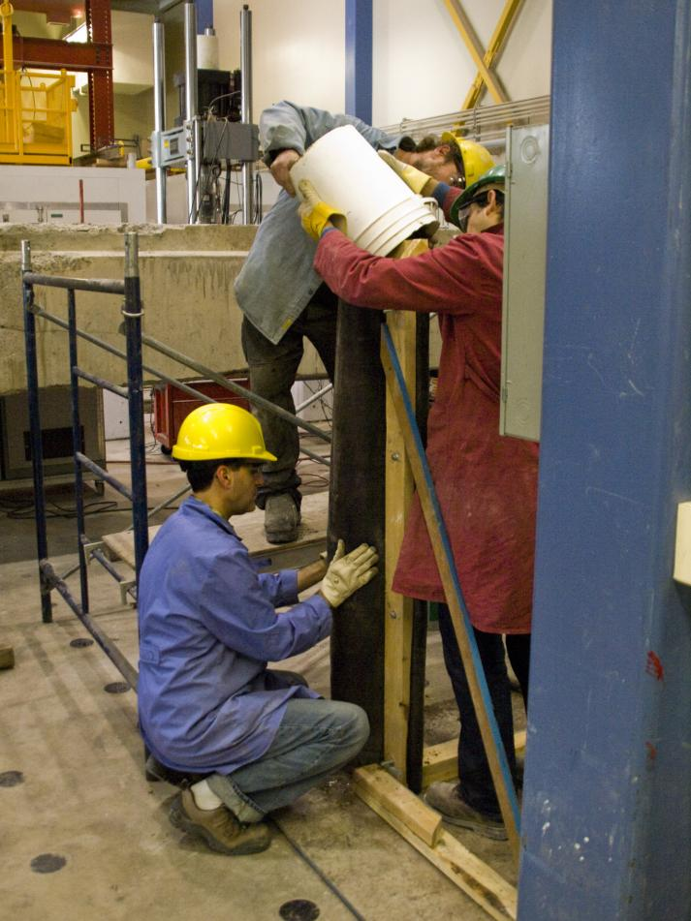Array

Test Setup and Instrumentation
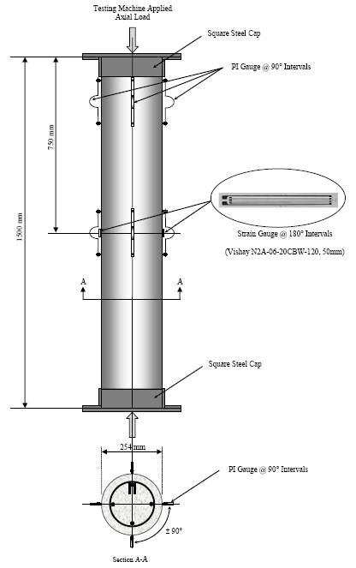Array

Companion Control Cylinders
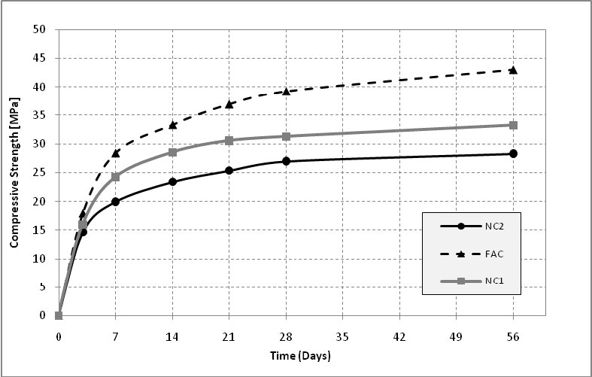Array

Schmidt Hammer Tests
Appendix C
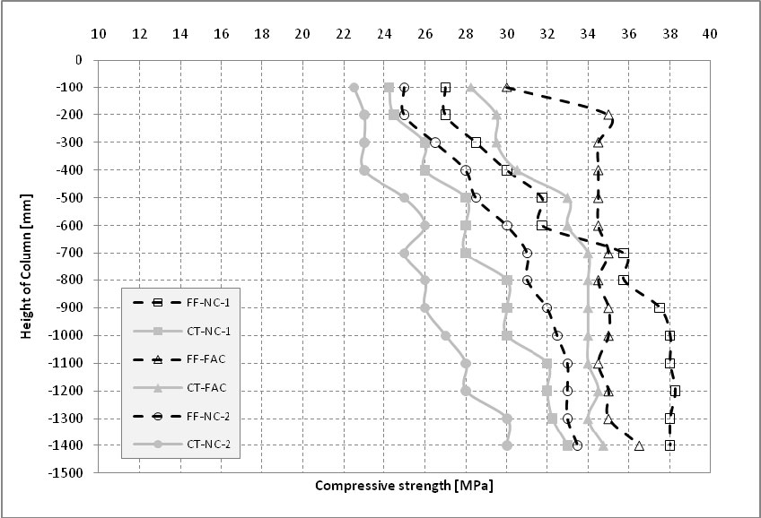Array
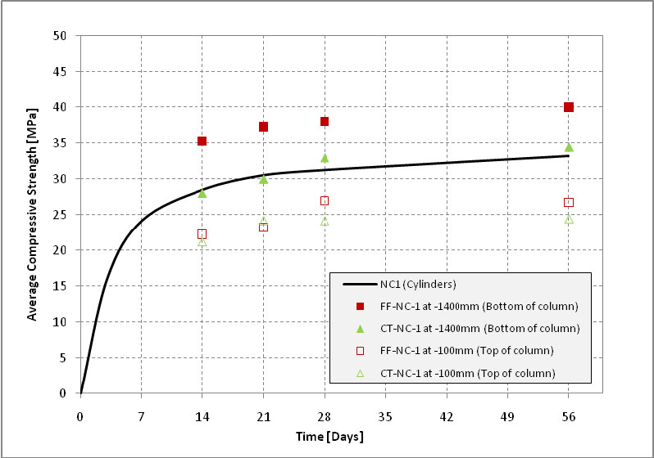Array
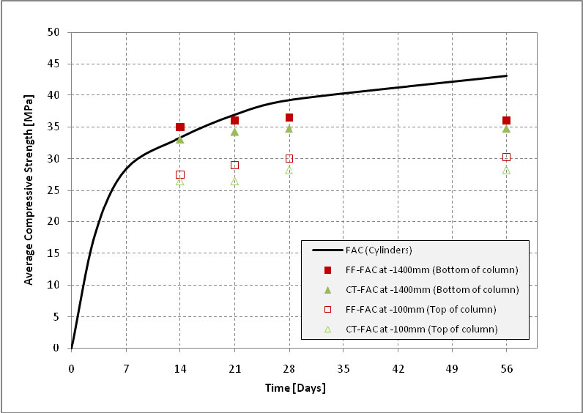Array
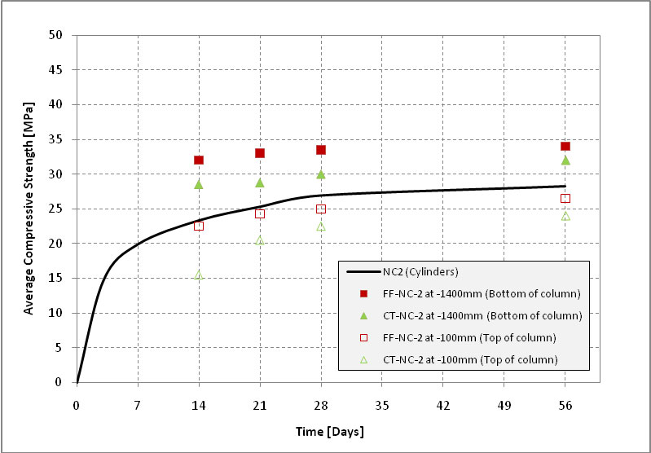Array

Column Compression Tests
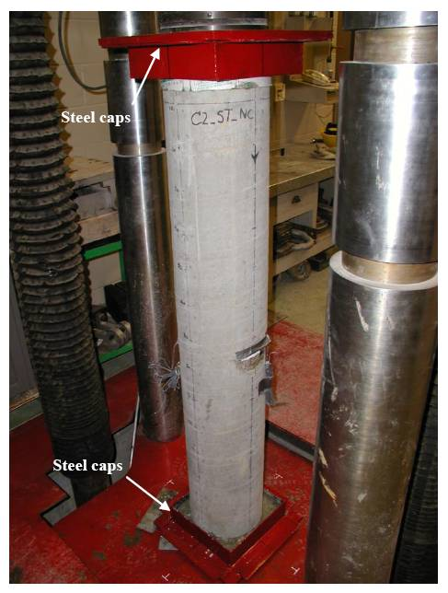Array

Test Results

Failure Patterns

Compressive Strength
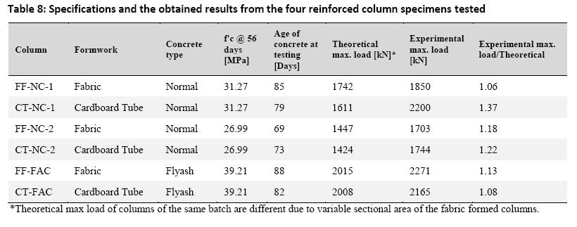Table 8: Specifications and the obtained results from the four reinforced column specimens tested
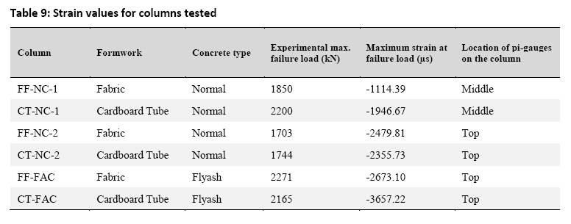Table 9: Strain values for columns tested
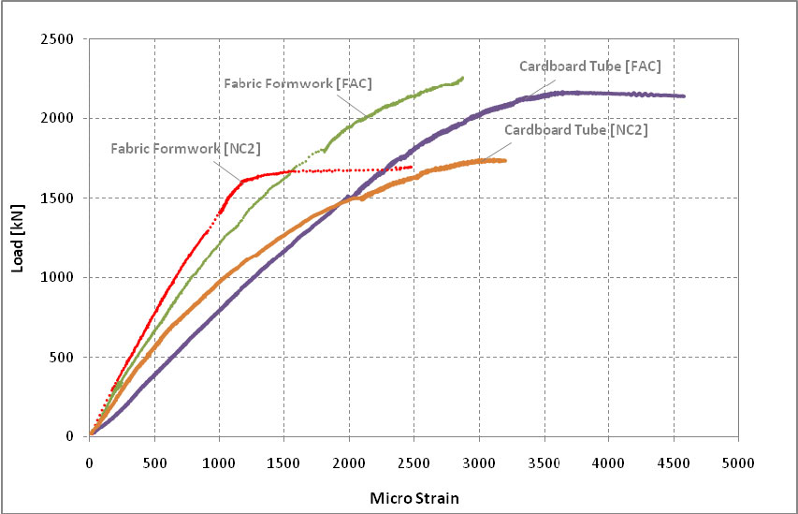Array
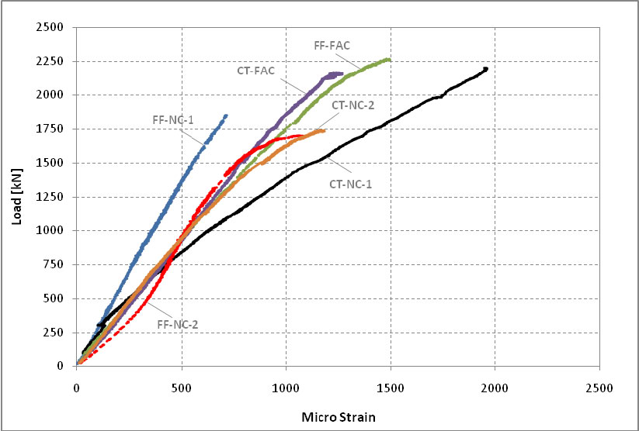Array
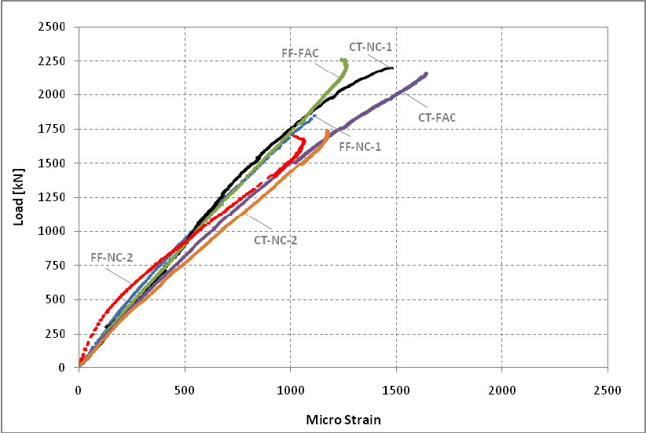Array
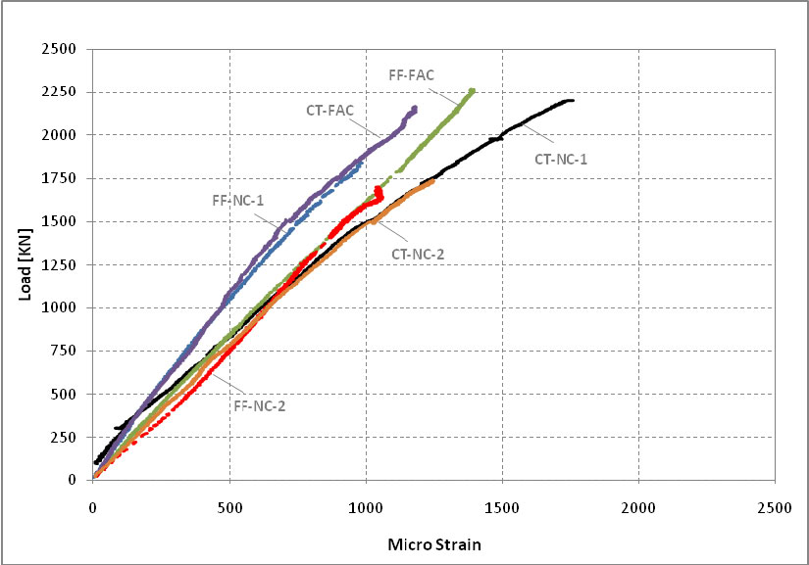Array
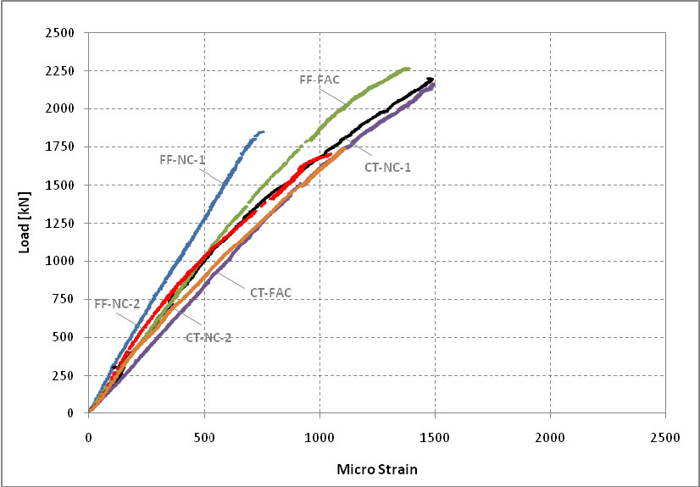Array
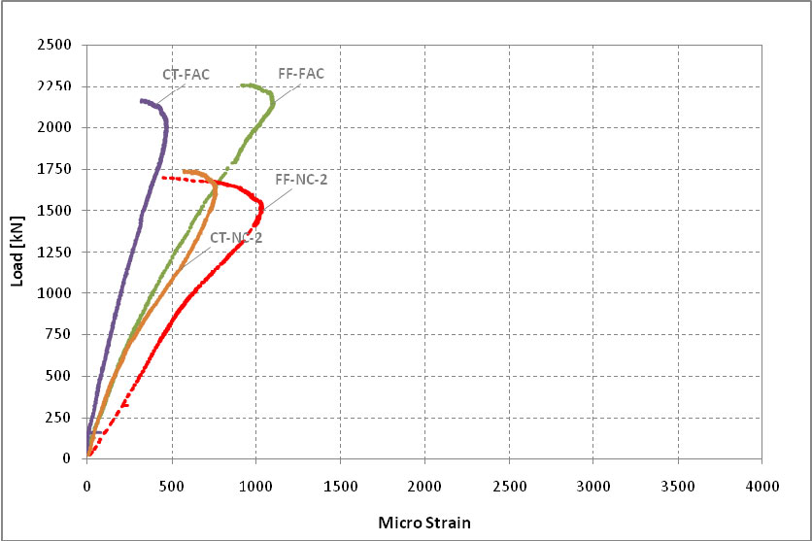Array
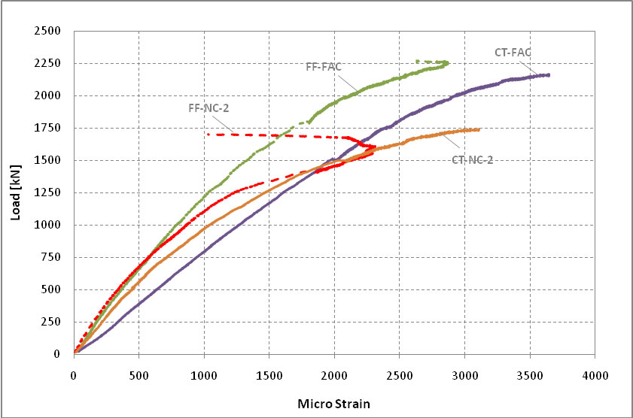Array
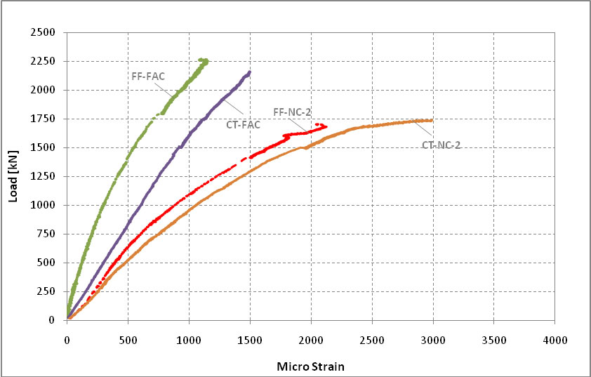Array
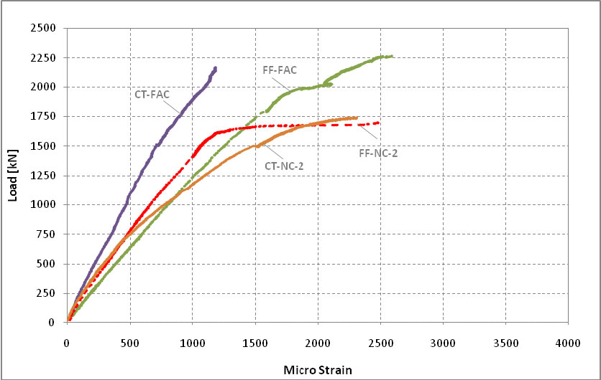Array
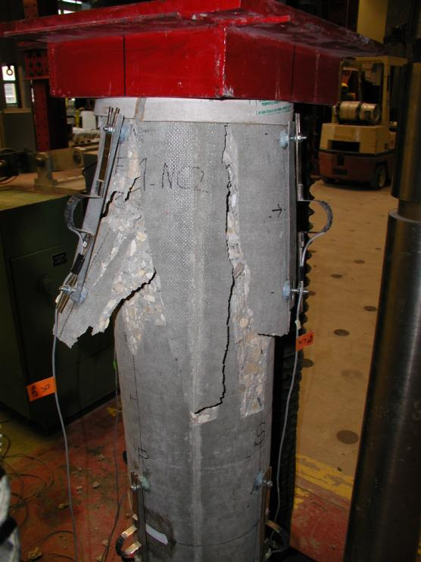Array
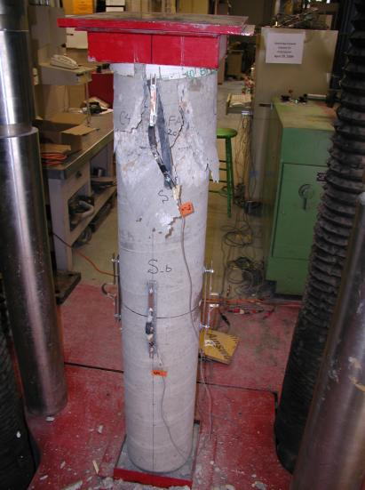Array
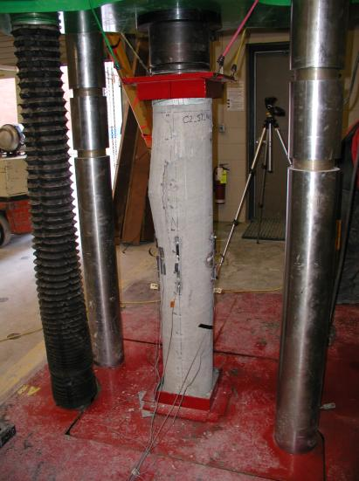Array
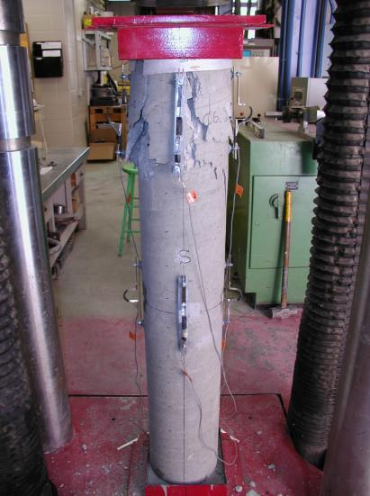Array
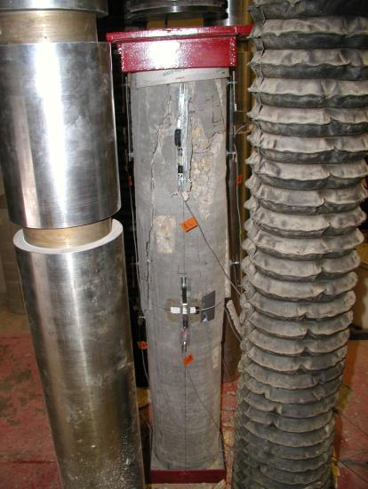Array
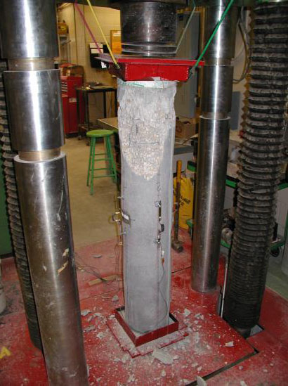Array
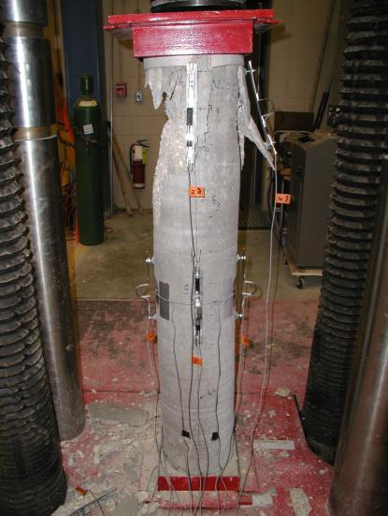Array
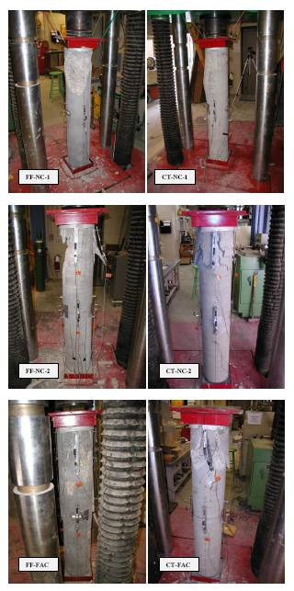Array

Lessons Learned About Fabric Formwork
http://www.fab-form.com/products/fasttube/fasttube_video.html
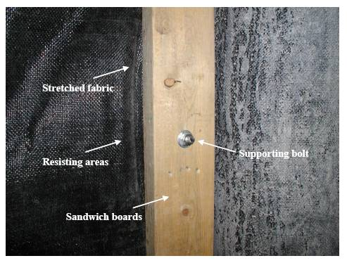Array
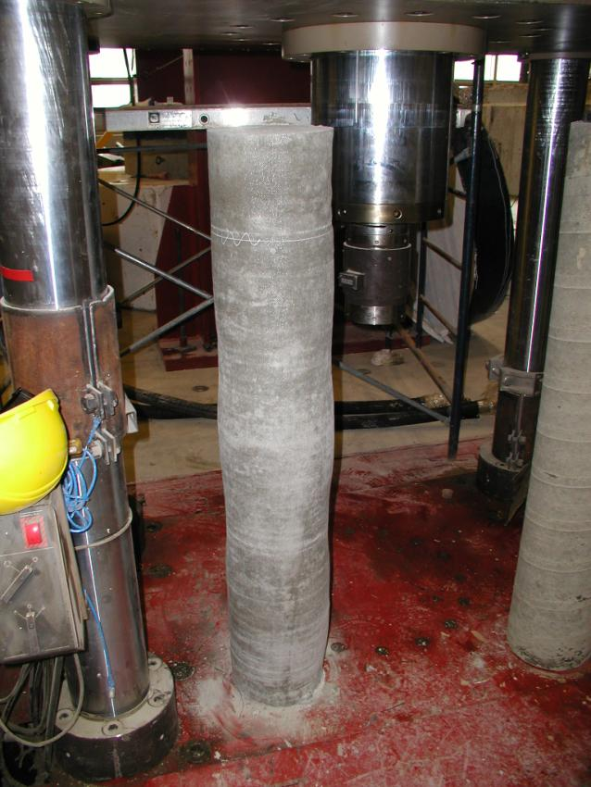Array
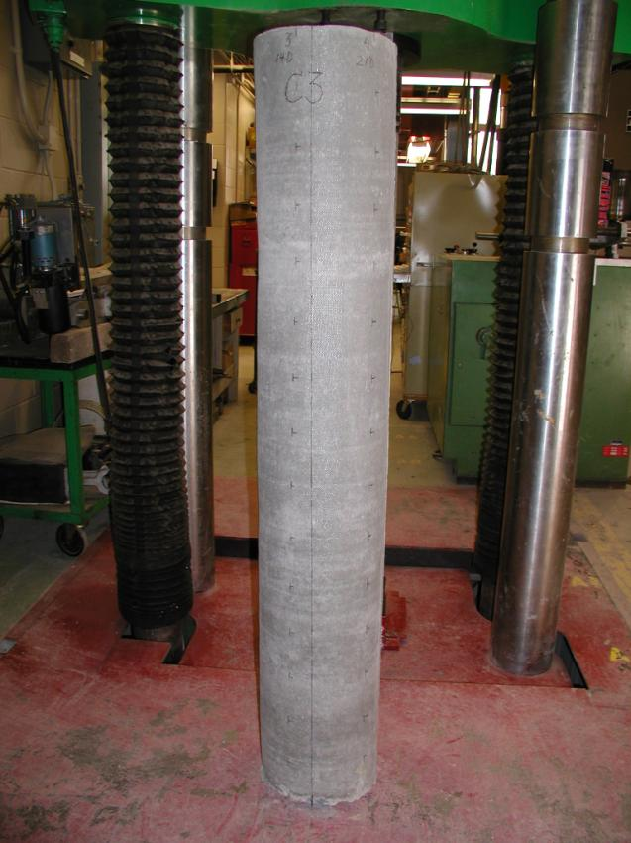Array

See Also
Place text here.

References
Concrete Test Hammer Manual.http://www.papworths.com.au/docs/2/Manuals/Schmidt%20Hammer%20Type%20N%20L%20NR%20LR%20Manual.pdf
“”Materials and Structures,
“”The Structural Engineer,

External Links
Place text here.

