PlayGround

experiment here

YouTube - Wikis in Plain English

Video Share Plugin Example
HIT WEBPAGE BACK ARROW TO RETURN TO THIS PAGE.
WIKIS in Plain English

START WITH 2 {AND END WITH 2 }Video Share Plugin
- Where videosite is one of the identifiers listed in Supported Services chapter
- and videoid is the identifier of the video at the respective site
- The parameters are optional. You start these with a ? and separate more of them by a &. Look in Parameters chapter
- The title is optional as well. Look in Examples chapter
- The video can be aligned by adding spaces on the left or right inside the curly brackets (like in the image syntax). Look in Examples chapter

Sample Gallery
Array
Array
Array
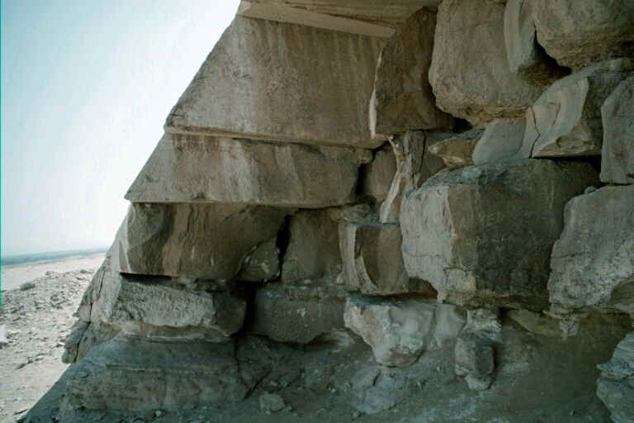Array
Array
Array
Array
Array
Array
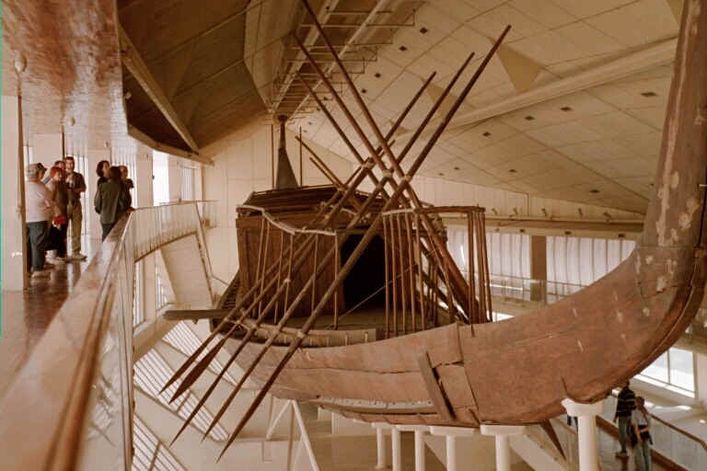Array
Array
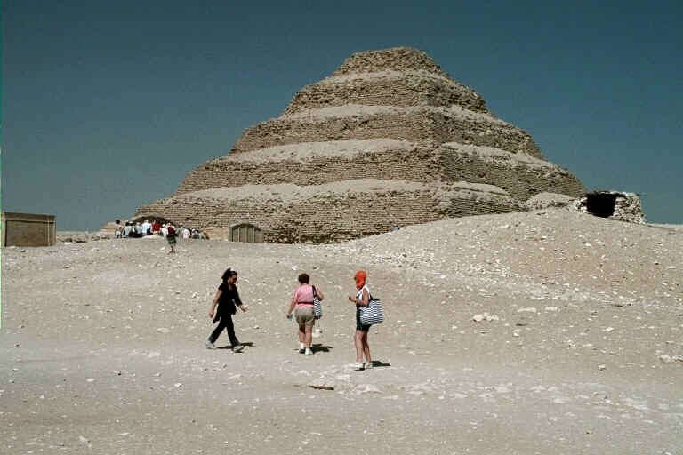Array

Group Users Plugin Example
{groupusers>user}}

