BACK TO MAIN TOC

Selection of Fabrics

Choice of Fabrics
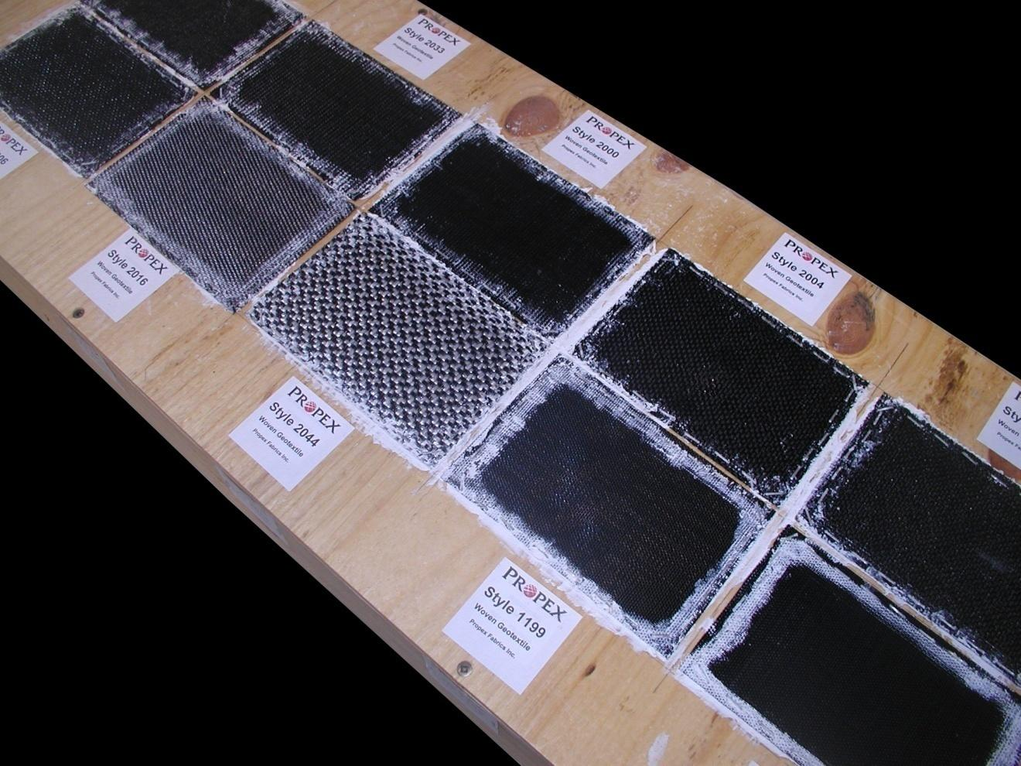Array
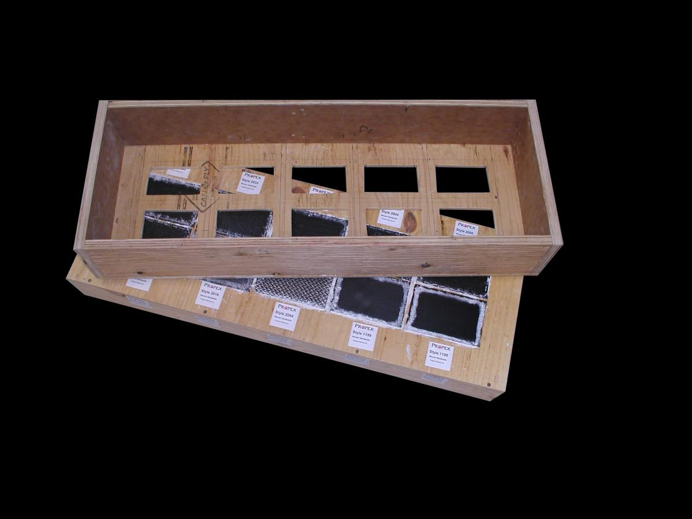Array
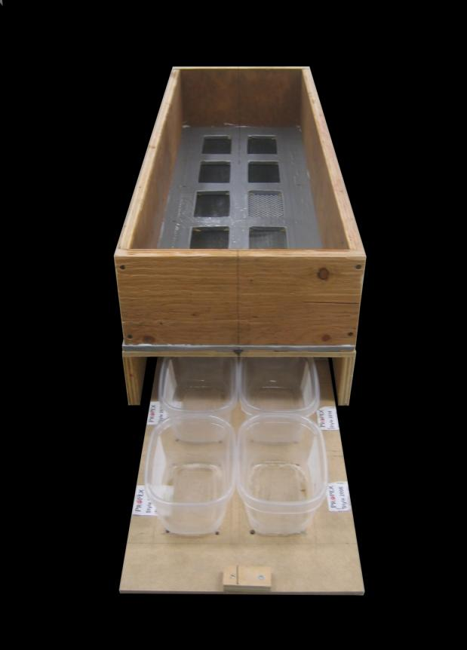Array

Fabric Tests Using Normal Concrete
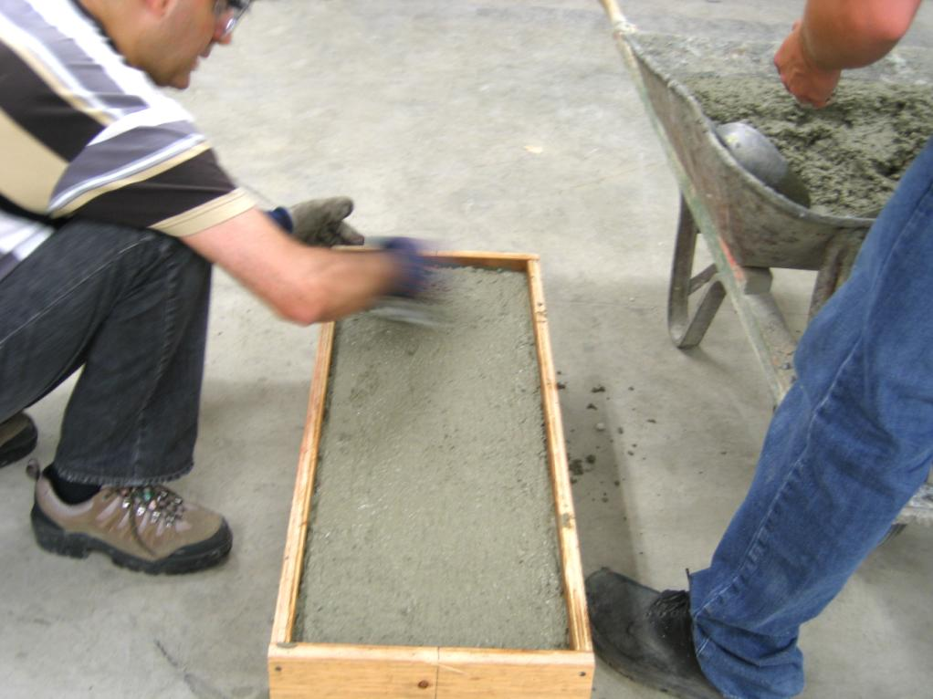Array
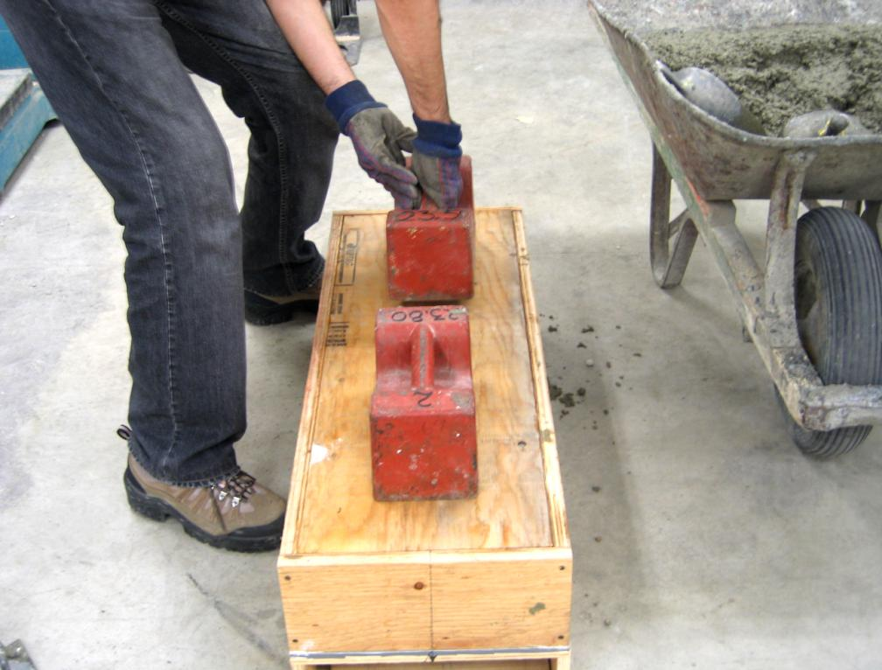Array
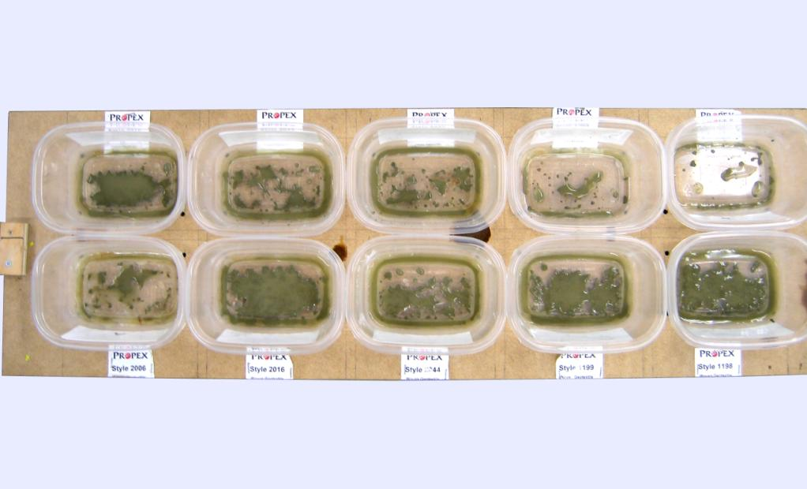Array
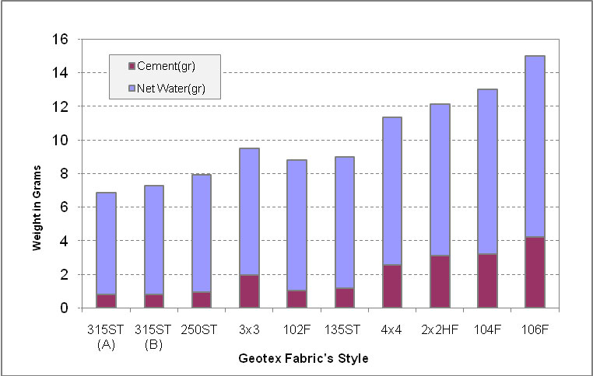Array
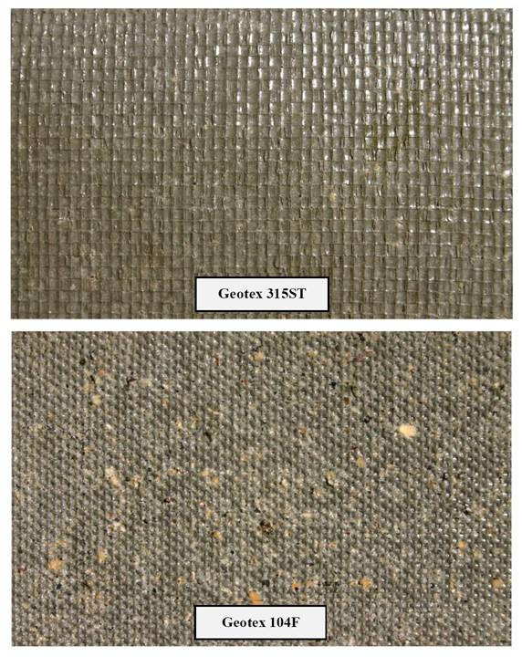Array
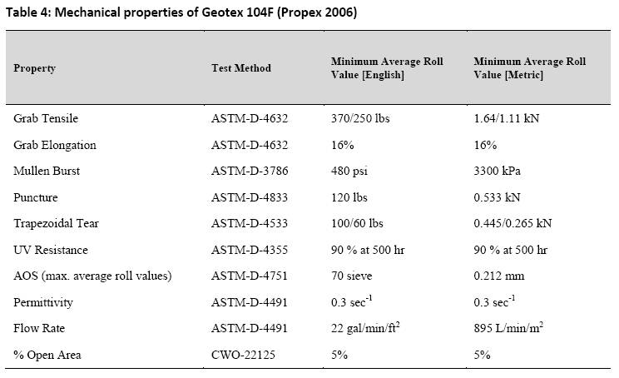Table 4: Mechanical properties of Geotex 104F (Propex 2006)
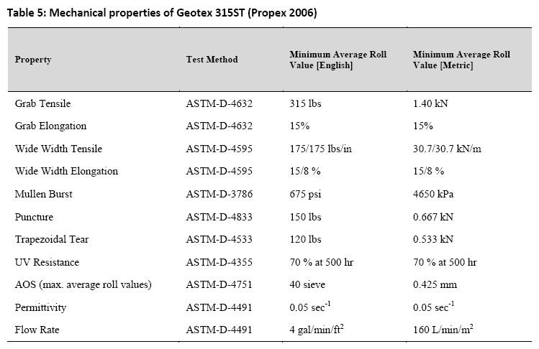Table 5: Mechanical properties of Geotex 315ST (Propex 2006)

Fabric Tests Using 30% Flyash Concrete
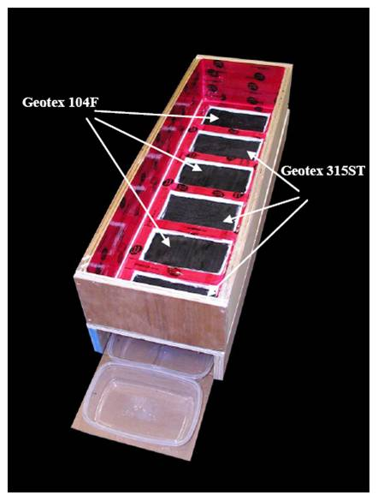Figure 14: Box made for Box Test 2

Results
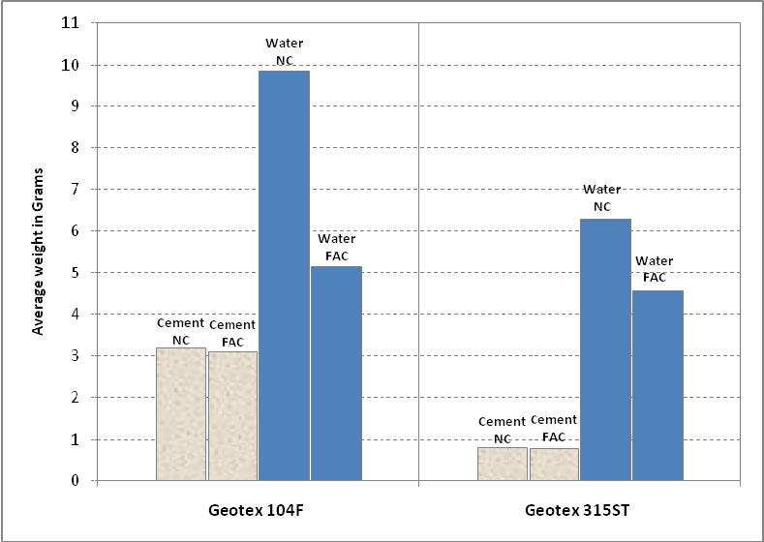Figure 15: The effect of flyash on the amount of bled water and cementitious material
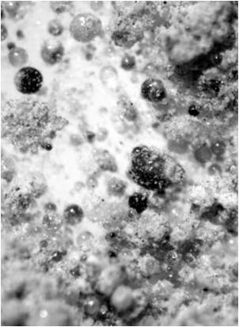Figure 16a: Microscopic picture of Pure Flyash with different sizes of flyash beads
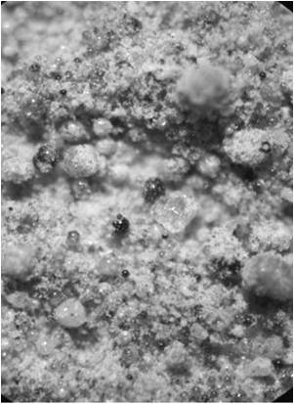Figure 16b: Microscopic picture of Material bled from Geotex 104F showing some flyash beads along with the fine aggregates (mostly cement)
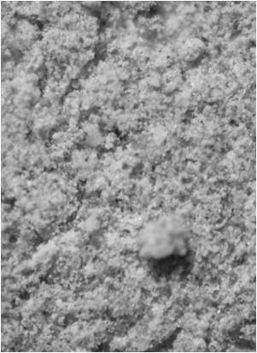Figure 16c: Microscopic picture of Material bled from Geotex 315ST with almost no flyash beads

See Also
Place text here.

References
Port Engineering.
“”High-tech Fibrous Material,
“”Encyclopedia of Coastal Science,
http://www.propexinc.com/
Brock White.http://www.brockwhite.com/
Candela/The Shell Builder.
Civil Engineering—ASCE,
Concrete International,
Use of Permeable Formwork in Placing and Curing Concrete.
“”Construction and Building Materials,
“”Concrete Construction,
Design and Control of Concrete Mixtures.
Fly Ash Facts for Highway Engineers.

External Links
Place text here.

